Project Name
Cyber Security


Submitted By
Student 1
Student 2
Session

Department of Cyber Security
Khwaja Fareed University of Engineering & Information Technology
Rahim Yar Khan
2025
Project Name

Submitted to
Supervisor Name

Department of Cyber Security
In partial fulfilment of the requirements
For the degree of

Bachelor of Science in Cyber Security

By
Student 1
Registration No Student 1
Student 2
Registration No Student 2
Session

Khwaja Fareed University of Engineering & Information Technology
Rahim Yar Khan
2025
DECLARATION

I/We hereby declare that this project report is based on my/our original work except for citations and quotations which have been duly acknowledged. I/We also declare that it has not been previously and concurrently submitted for any other degree or award at Khwaja Fareed University of engineering & Information Technology or other institutions.

Reg No : | _________________________ | Reg No : | _________________________
Name : | _________________________ | Name : | _________________________
Signature : | _________________________ | Signature : | _________________________
Date : | _________________________ | Date : | _________________________

APPROVAL FOR SUBMISSION

I certify that this project report entitled Project Name was prepared by Student 1 and Student 2 has met the required standard for submission in partial fulfilment of the requirements for the award of Bachelor/Masters of Science in Cyber Securityat Khwaja Fareed University of Engineering & Information Technology.

Approved by:

Signature : _________________________

Supervisor : Supervisor Name

Date : _________________________
MEETING LOG

ACKNOWLEDGEMENT

I/We would like to thank everyone who had contributed to this project. I/We would like to express my/our gratitude to my/our Project supervisor, Supervisor Name for his/her invaluable advice, guidance, and his/her enormous patience throughout the development of the project.
In addition, I/we would also like to express my/our gratitude to my/our loving parents and friends who had helped and given me/us encouragement.
ABSTRACT

The Prisoner Management System (PMS) is an effective administration and management system with the objective of providing an easy effective and efficient mechanism beneficent for the prison department. The Prisoner Management System (PMS) was marked by multiple complexities and hurdles including multiple records keeping, manging visitors, time consuming, human error, calculation of correct release dates and duty schedule of prison staff.
This system removes all of these hurdles and beneficent the system by easily keeping multiple records of prisoners and other prison staff. This system easily keeps records of different visitors, prisoners’ whole details and also automatic tells us about differ prisoners release date. System can update, delete the records of working staff (Jailors, guards, cook and cleaners). System will be much beneficial, can write First Investigation Report (FIR) and then print out it. If case solved, FIR can be deleted. At the end, prisoner release date system will generate the prisoner report card and you can generate it.
There is no chance of mistake. As criminals record is increasing day by day it is difficult to handle too much prisoners’ records and keep them at safe place. System removes different hurdles of jailor. Records of prisoners will remain even after the release of the prisoners which will later help in tracking of different prisoners. For tracking a prisoner later on by the government issuance, system will not have any delete option for a prisoner’s record that will also help in future getting information about prisoners later.

TABLE OF CONTENTS

Chapter 1 13
INTRODUCTION 13
1.1. Background 13
1.2. Heading Level 2 13
1.2.1. Heading Level 3 13
1.2.1.1. Heading Level 4 14
1.3. Introduction 14
1.4. Problem Statement 15
1.5. Objective 15
1.6. Project Scope 15
1.7. Advantages of the System 15
1.8. Relevance to the Study Program 15
1.9. Chapter Summary 15
Chapter 2 16
EXISTING SYSTEMS 16
2.1. Existing Systems 16
2.2. Drawbacks in Existing Systems 16
2.3. Examples of Existing Systems 16
2.4. Need to Replace Existing Systems 16
2.5. Chapter Summary 16
Chapter 3 17
REQUIREMENT ENGINEERING 17
3.1. Proposed System 17
3.2. Understanding the System 17
3.2.1. User Involvement 17
3.2.2. Stakeholders 17
3.2.3. Domain 17
3.2.4. Needs of System 17
Table ‎3.1 User Needs of System 17
3.3. Requirement Engineering 17
3.3.1. Functional Requirements 17
3.3.2. Non-Functional Requirements 18
3.3.3. Requirements Baseline 18
3.3.4. Need to Feature Mapping 18
3.4. Gantt Chart 18
3.5. Hurdles in Optimizing the Current System 18
3.6. Chapter Summary 18
Chapter 4 19
DESIGN 19
4.1. Software Process Model 19
4.1.1. Benefits of Selected Model 19
4.1.2. Limitations of Selected Model 19
4.2. Design 19
4.2.1. Methodology of the Proposed System 19
4.2.2. Entity Relationship Diagram 19
4.2.3. UML Diagrams 19
4.2.3.1. Use Case Diagram of the System 19
4.2.3.2. Class Diagram of the System 19
4.2.3.3. Activity Diagram of the System 19
4.2.3.4. Sequence Diagram of the System 19
4.2.3.5. Component Diagram of the System 19
4.3. Chapter Summary 19
Chapter 5 20
DATABASE 20
5.1. Database Introduction 20
5.2. Selected Database 20
5.2.1. Reasons for Selection of the Database 20
5.2.2. Benefits of the Selected Database 20
5.2.3. Limitations of the Selected Database 20
5.3. Database Queries 20
5.4. Database Tables 20
5.5. Database Schema Diagram 20
5.6. Chapter Summary 20
Chapter 6 21
DEVELOPMENT AND IMPLEMENTATION 21
6.1. Development of the Computer Program 21
6.2. Implementation Strategy 21
6.3. Tools Selection 21
6.3.1. Hardware 21
6.3.2. Software 21
6.4. Coding 21
6.5. User Interface 21
6.5.1. Description 21
6.5.2. Interface Screenshots 21
6.6. Program Deployment 21
6.7. Chapter Summary 21
Chapter 7 22
TESTING 22
7.1. Introduction 22
7.2. Testing Methods 22
7.3. Comparison 22
7.4. Software Evaluation 22
7.4.1. Testing Strategy 22
7.4.2. Test Plans 22
7.4.3. Test Cases 22
7.4.4. Test Report 22
7.5. Chapter Summary 22
REFERENCES 23
APPENDIX (Optional) 24

LIST OF FIGURES

Figure ‎1.1 Figure Caption 14

LIST OF TABLES

Table ‎1.1 Table Caption 14
Table ‎3.1 User Needs of System 17
Table ‎3.2 Functional Requirement 01 17

INTRODUCTION

Background
This format is to be followed for the Final Year Projects of the Department of Computer Science. Page layout for this format is A4 with Normal Margins. Each chapter must be started by giving a Chapter No. in the first line of the page like Chapter 1. The Chapter No. must be of size 14 pts., Times new Roman, bold and left aligned. A space of 6pts. must be added after Chapter No.
In the next line immediately after Chapter No, Chapter name must be mentioned like INTRODUCTION which must be of size 14 pts., Times New Roman, all Caps, centred and bold. A space of 6 pts. must be added after Chapter Name.
Paragraph headings must be numbered according to Chapter No. If paragraph heading is under Chapter 1 then it must be like 1.1., 1.2. and so on. If it is under Chapter 2 then it must be like 2.1., 2.2. and so on. Paragraph headings must be of size 12, Times New Roman, Bold and left aligned. In this format Sub-headings can be used up to level 4 i.e. you can maximum go up to 1.1.1.1. (under heading 1.1.) after that if needed, bullets can be used. Space of 6 pts must be added after each heading. Examples of headings are given below.

Heading Level 2
Text for the paragraphs must be justified and font size must be 12 pts. Font style must be Times New Roman. Each paragraph must start with a tab space of 0.6 in the first line only. Space of 6 pts must be added after each paragraph. Line spacing for paragraph text must be 1.5.

Heading Level 3
Each chapter must have header. Header must be Chapter No followed by name of the chapter like Chapter 1 Introduction. Its font style must be Times New Roman, size must be 12 pts and font must be small caps.

Heading Level 4
Page numbers for the initial pages (before starting of chapters) must be capital roman letters (I, II, III etc) of style Times New Roman, size 12 and must be inserted in bottom right footer of every page. Page numbers for initial pages (before chapters) must be started from second page and title page must not be assigned any page number.
- Pages number for rest of the document starting from chapter 1 must be simple numerical numbers (like 1, 2, 3 etc) and must be inserted in bottom right footer. Font style must be Times New Roman at size 12.

Introduction
All figures in the document must be centralized. Figure captions must be given below the figures, must be centralized, style should be Times New Roman at size 10 as shown below.
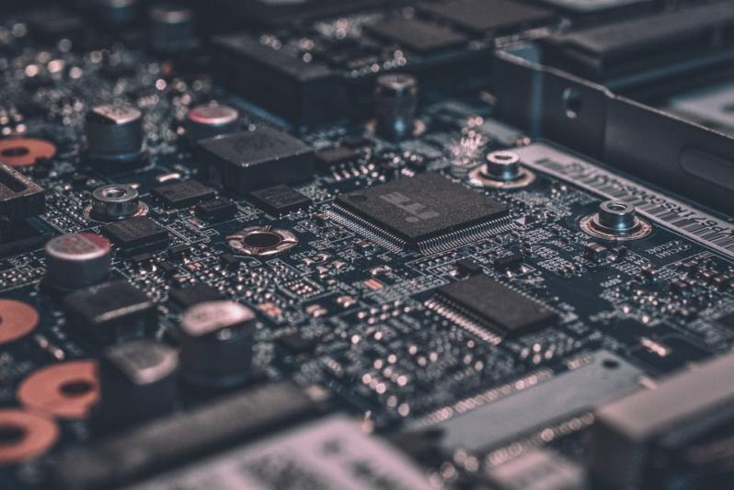
Figure ‎1.1 Figure Caption
All tables in the document must be given captions. Captions must be above table, left aligned, Font style must be Times New Roman at size 10 as shown below.
All tables and figure captions must be according to the chapter no.
At the end of the document references must be added [1]. References must be autogenerated list of citations used across your document [2]. Format to be used for references is IEEE [3].
Table ‎1.1 Table Caption
Table Data | Table Data

Problem Statement

Objective

Project Scope

Advantages of the System

Relevance to the Study Program

Chapter Summary

EXISTING SYSTEMS

Existing Systems

Drawbacks in Existing Systems

Examples of Existing Systems

Need to Replace Existing Systems

Chapter Summary

REQUIREMENT ENGINEERING

Proposed System

Understanding the System

User Involvement

Stakeholders

Domain

Needs of System
SR # | Needs | Need ID
1
2

Table ‎3.1 User Needs of System

Requirement Engineering

Functional Requirements
Table ‎3.2 Functional Requirement 01
Functional Requirement ID | FR-01
Name
Description
Input
Output
Precondition
Postcondition

Non-Functional Requirements

Requirements Baseline

Need to Feature Mapping

Gantt Chart

Hurdles in Optimizing the Current System

Chapter Summary

DESIGN

Software Process Model

Benefits of Selected Model

Limitations of Selected Model

Design

Methodology of the Proposed System

Entity Relationship Diagram

UML Diagrams

Use Case Diagram of the System

Class Diagram of the System

Activity Diagram of the System

Sequence Diagram of the System

Component Diagram of the System

Chapter Summary

DATABASE

Database Introduction

Selected Database

Reasons for Selection of the Database

Benefits of the Selected Database

Limitations of the Selected Database

Database Queries

Database Tables

Database Schema Diagram

Chapter Summary

DEVELOPMENT AND IMPLEMENTATION

Development of the Computer Program

Implementation Strategy

Tools Selection

Hardware

Software

Coding

User Interface

Description

Interface Screenshots

Program Deployment

Chapter Summary

TESTING

Introduction

Testing Methods

Comparison

Software Evaluation

Testing Strategy

Test Plans

Test Cases

Test Report

Chapter Summary

REFERENCES

[1] | H. J. Künzel, “Effects of voice disguise on speaking fundamental frequency,” International Jouranl of Speech language and the Law, vol. 7, no. 2, 2000.
[2] | J. Mariethoz and S. Bengio, “Can a Professional Imitator Fool a GMM-Based Speaker Verification System?,” IDIAP Research Institute, Martigny, Switzerland, 2006.
[3] | E. Zetterholm, Voice Imitation : A Phonetic Study of Perceptual Illusions and Acoustic Success., 2003, p. 160.

APPENDIX (Optional)

